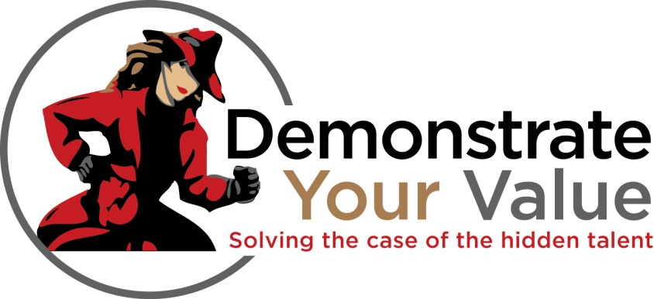
CDPI Fall Conference Breakout Sessions
- Don’t Brand Me! A Strategy for helping liberal arts students convince employers,
Presented by James Jeffries from Wabash College

- Demonstrate your Talent: Be Seen, Be Heard, Be You,
Presented by Sam Turpin from View You

- KEY Careers: Creating Career Clarity,
Presented by Brandon Bute from Ball State University

- Assessment Strategies that help Tell our Story,
Presented by Jim McAtee from Ball State University and Rachel Landis from IPFW

- Using Experiential Education and Career Development to Engage Student Leaders,
Presented by Justin Zuschlag from Indiana University

- Hands on Activities that Assist Students in Creating Their Success Stories,
Presented by Cathy Mullet from Ball State University

- They Don’t Know What They Don’t Know: Using the Conscious Competence Ladder Model to Engage Students,
Presented by Cindy Price Verduce from Indiana Tech

- Understanding Poverty and Its Impact on Our Students,
Presented by Tim Ross from Ivy Tech Community College

- INdorsed Career Ready Program,
Presented by Liz Bushnell from Manchester University

- ICI Collaborative Career Initiative: One Voice Stronger Together,
Presented by Richard Ludwick from Independent Colleges of Indiana Inc.

